**Detailed Business Specific Requirements:-**

**Theme**: Existing IT system for internal agencies of MoJS

**Applications**: "**WIMS expansion-WRIS**

**Use Cases:-** "Flood Inundation Mapping”-**FA-UC-02**

**Other linked Use Case :-** Flood prone area assessment (FPA)(FA-UC-03)& Flood plain Zoning(FA-UC-05)& other purposes like post damage assessment.

**Description**:-Remote sensing data already plays a significant role in water Resources management, but further, advancement in the technology promise to support sustainable water resource management and development in more comprehensive and holistic manner. Earth Observation Satellite (EOS)-04 or RISAT -1 A is follow on to RISAT -1 and launched in February 2022 based on the recommendation from planning Committee of space applications Management System (PC-SAMS), Subsequent to evaluation of its needs aspects by various Ministry/Dept. The EOS-04 is first of its kind mission that went through a series of deliberations with planning committee, of Space Applications Management systems (PC-SAMS) mechanism, wherein it intended utilization plan was endorsed by the user Ministries, and funding support was also provided by them, including launch cost. Ministry of Jal Shakti (MoJS) is one of such agency. The Image acquired from RISA-1A at regular intervals af1re being used for various application in water resources.

**Used By (End Users):-** Planners, Decision makers, administrator, academicians, SDMA and NDMA, Insurers and General public.

**Priority**:- **High Priority :** This use case is important for post disaster management, assessment, deployment of disaster response teams, planning of mitigation measures and as an input to calibrate and validate models on flood inundation forecasting.

**Phase:-** **Phase**  **2:** DSS Development of WARIMS

**Governance Need (Business Problem):-**

RISAT-1A acquires large spatial datasets at regular interval for PAN India for which high computational resources for continuous fetching of satellite data, archiving and processing for intended purpose. This further requires a visualization platform for GIS query based decision support system (DSS) for utilization among all stakeholders**.**

**Output:-** Estimated Spatial Flood Extent Near real-time flood inundation maps along with reports

**Expected Outcome:-** Post-disaster management, assessment, deployment of disaster response teams, planning of mitigation measures and as an input to calibrate and validate models on flood inundation forecasting.

**Visualization:-**

**1. Map of inundated areas corresponding to each flood event with date**

* **Political boundary**
* State
* District
* Town/village/ Panchayat boundary
* Boundaries of Assembly and Parliamentary constituencies
* **Hydrological Boundary**
* Basin,
* Sub-Basin
* River
* Base Layers
* **All types of base layers as available should be displayed such as:-**
* Infrastructure
* Water Projects
* Population
* Places
* Crop Area
* LULC
* Embankments
* Built-up area

**User Selection:-** The default screen will appear as a terrain map of India. By zooming, the required state, district, river, or inundated area can be searched. There will be a “Search” button also to facilitate searching for a particular district or river by name. When user clicks on an inundated area, the table mentioned below will pop up on screen with the following information:

1. Name of river basin
2. Name of river
3. Name of State/District
4. No. of villages/towns affected
5. Population affected
6. Length of road/railway line affected
7. No. and type of houses and other infrastructure affected
8. No. and type of critical structures (hospitals, fire stations, power plants and sub-stations, water supply and sewerage treatment plants, structures of historical and strategic importance etc.) affected, if any
9. Crop area damaged and estimated value of loss in Rs Lakhs
10. Dates of flooding with time series of images (historical spatial estimated flood extent)
11. Estimated Damage

**Frequency of Up-dation:-** As soon as RISAT-1A data is acquired (near real time)

**Measure of Success:-** Based on feedback of stakeholders

**Input Data Required:-**

|  |  |  |
| --- | --- | --- |
| **Data** | **Unit** | **Type** |
| SAR data | Satellite Imagery | ISRO/RISAT-1A / NWIC |
| Population density map with village/town as unit | Decimal Number | Census / NWIC |
| LULC map with special reference to area under crops | Map | NRSC/ Satellite Image / NWIC |
| Map layer showing railway network | Map | NRSC/ Satellite Image / NWIC |
| Map layer showing road network | Map | NRSC/ Satellite Image / NWIC |
| Map layer showing important structures like hospitals, fire stations, power plants and substations for power supply, water supply and sewerage treatment plants, police stations, structures of historical and strategic importance, nearest flood shelter etc | Map | Sol/ NRSC/ High resolution Satellite Images / NWIC |
| Length of road/railway line affected | Decimal number | Transportation network layer prepared in-house / NWIC |

**Process:**

**Algorithm/Tools:-**

**Step 1:** Fetch all base layers as listed above,

**Step 2:** **Fetch recently available RISAT-1A satellite data**

**Step 3:** Processing the SAR data (RISAT-1A) preparation of water masks from satellite data. The steps are as follows:

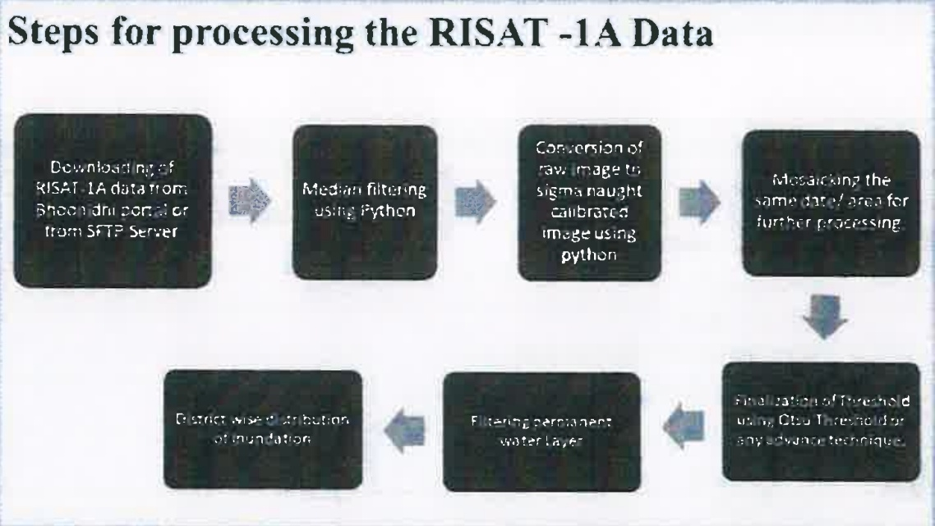

**Step 4:** Superimpose the water masks on the natural water bodies prepared in Step-1 and derive the flood-inundated areas

**Step-5:** Superimpose the flood inundated maps on available village/town/city maps, transportation network, population density map, crop area map and other infrastructure maps and find out no. of village/towns affected, number of people affected, length of road/railway line affected, crop affected, no. of other important/ critical infrastructure affected etc.

**Step 6:** Estimate the damages for the chosen administrative unit as applicable.

**Step 7:** Outputs displayed on a GIS platform.

**Step 8:** Chart of estimated flood extent at selected location pixels.

**Step 9:** Provide data download option in multiple formats i.e. .pdf., .csv, xls, .png

**Data Validation:-**

**Software Technologies:-**  Python3 and open-source GIS platform or any other

**Dependencies & Risks:** Data availability, permission to fetch data, inability to detect flood depths and distinguishing between & Risks different types of flood etc.

**User Acceptance Testing (UAT):-** CWC, NRSC, SDMA and NDMA

**Development Responsibility:** HARSAC

**References:-**

1. https://ndem nrsc.gov.inflogin.php malarial

2. https:/ibhuvan-appl.nrsc.qov.in/disaster/disaster.php?id=flood

3. https:/ibhoonidhi.nrsc.gov.in/bhoonidhizhome.html

**---End of Document---**